Primary:

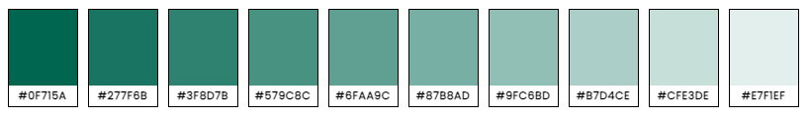

Neutral:

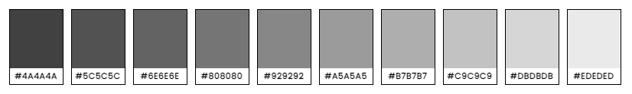

Accents:

